Weekly report

1. **My *Goals* from last week**
   * Objective 1: Assemble new OpenROV
   * Objective 2: Replace old OpenROV’s thrusters with the T100s
2. **My *Accomplishments* this week**
   1. Objective 1:
      1. We finished assembling the new OpenROV! Pictures of the process are shown in Figure 1

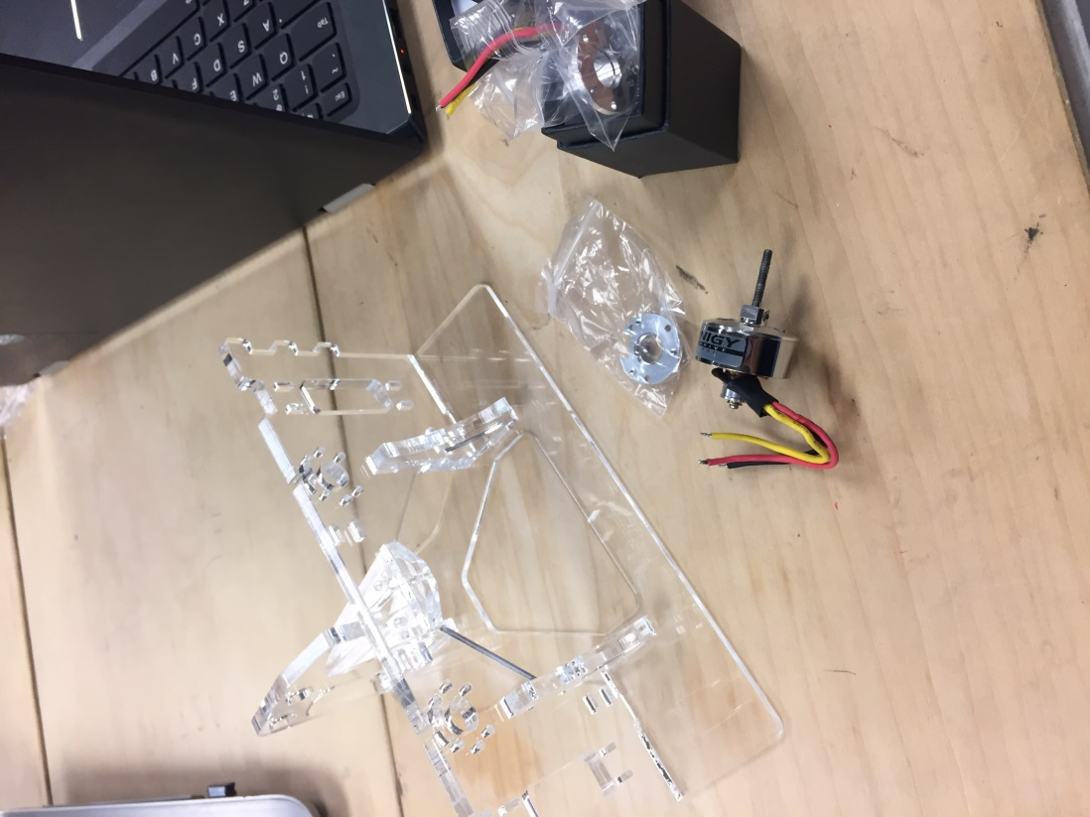 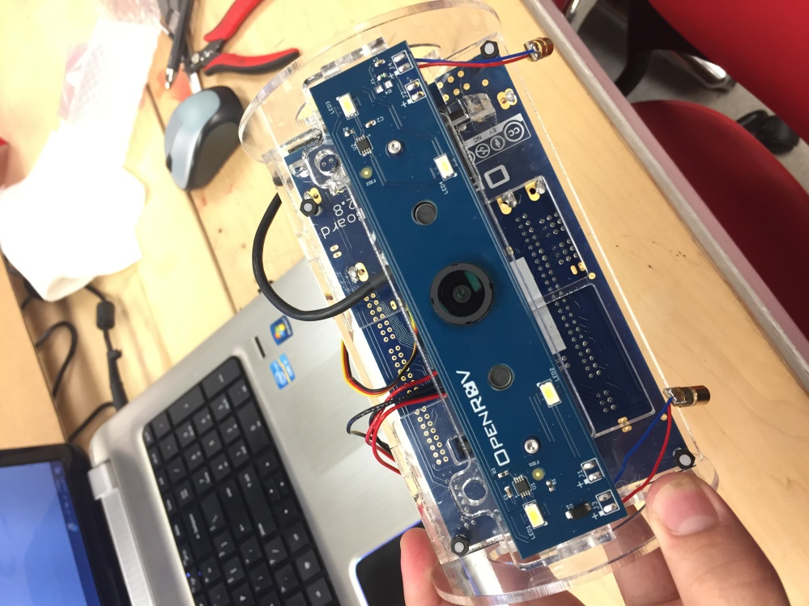

Figure 1. Assembling the new OpenROV

* 1. Objective 2:
     1. Successfully mounted the T100 thrusters on the new OpenROV. Designed a couple of brackets using the laser cutter to mount the vertical thruster. Pretty pictures in Figures 2 and 3.

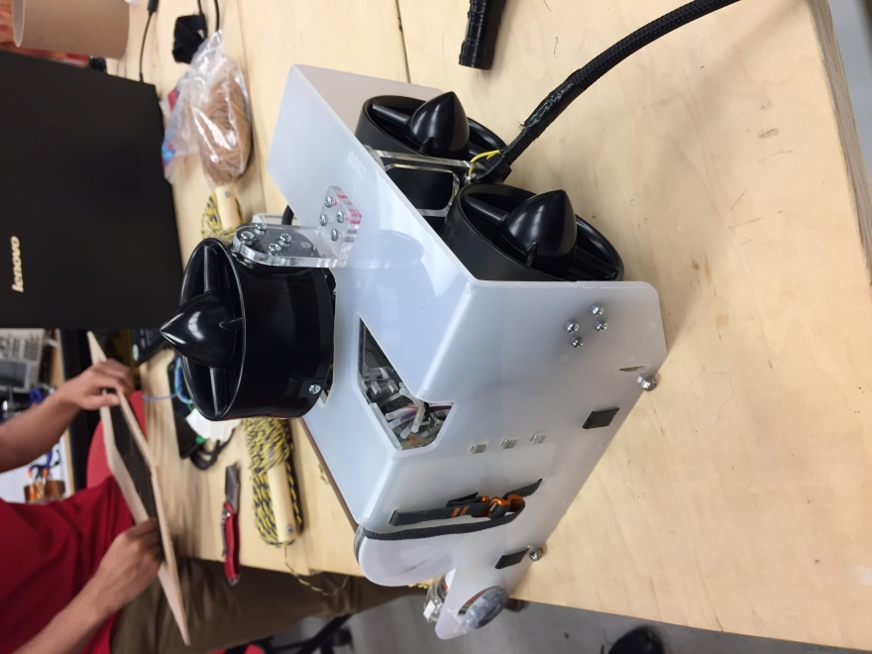 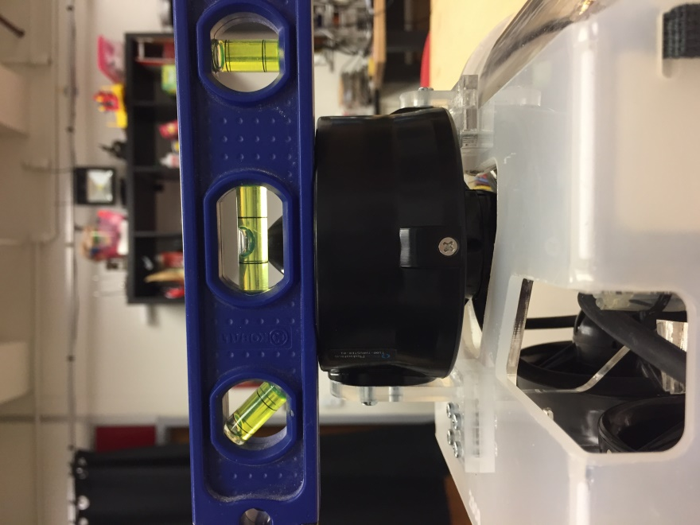

Figure 2. Old OpenROV with T100 thrusters

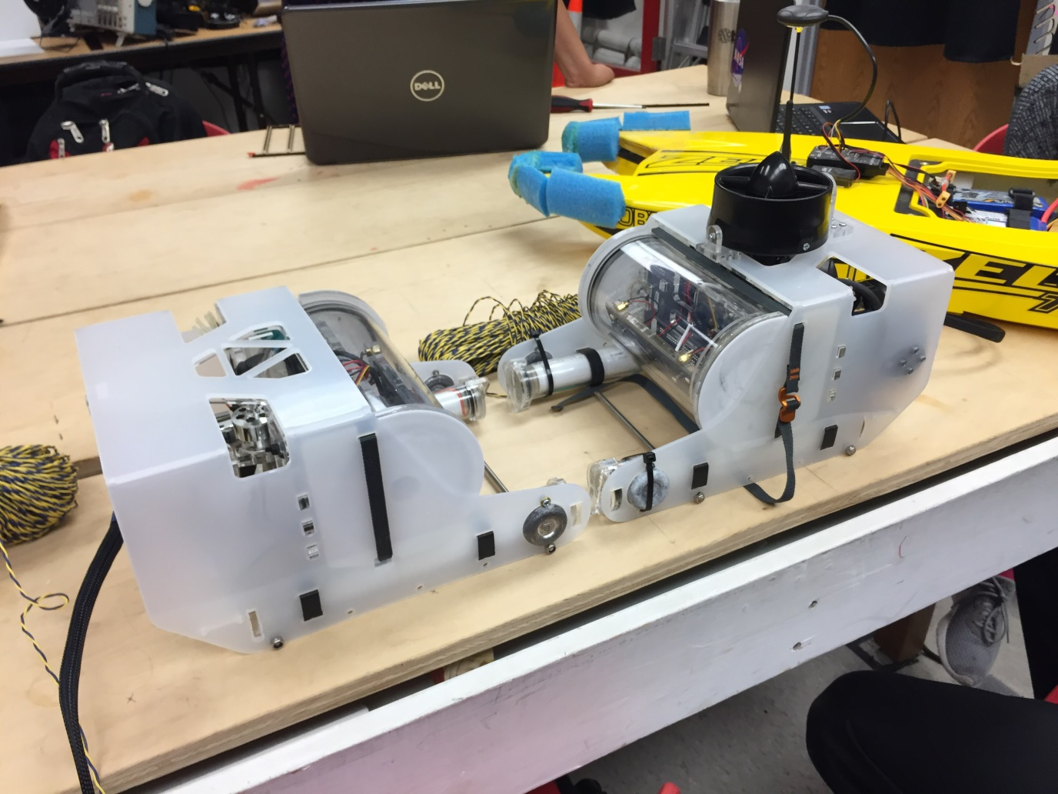

Figure 3. Both OpenROVs with the Zelos Twin Boat

1. **My *Goals* for next week**
   * OpenROVs

* Make the modified ROV neutrally buoyant
* Take video of the ROVs doing cool ROV stuff
* Zelos Twin Boat
* Figure out how this thing works
* Take video of it going super fast (bayou suggested location)
* Give it some UH swag

1. **What I need Dr. Becker to do:**
   * Help us find a place to test underwater